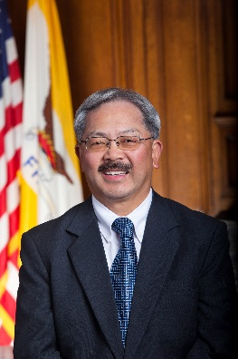City and County of San Francisco, Office of Mayor Edwin M. Lee

The December 2, 2015, SFPD officer involved shooting of Mario Woods shook the trust for many residents of this city. The following day, Mayor Lee issued a statement expressing sympathy and called for an immediate case review. Since this tragedy, the City has been working closely with city residents and leaders from law enforcement agencies, city departments, community and faith based organizations to outline key reforms, including the review of the San Francisco Police Department’s use-of-force policies. In order to build community trust, the City will take the necessary steps to ensure similar incidents will focus on the sanctity of life as well as officer safety.

Public Safety Reforms and Updates

* 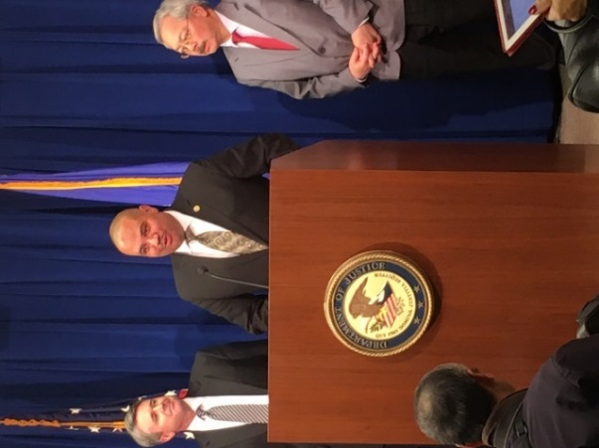**U.S. Department of Justice Review**

Mayor Lee with SFPD Chief of Police Greg Suhr requested the assistance of the U.S. Department of Justice to conduct a review of the San Francisco Police Department:

* 1. The U.S. Department of Justice, Office of Community Oriented Policing Services (COPS) will now do a collaborative reform review of the Police Department’s policies, procedures, and training related to use-of-force and to develop an edged/other weapon strategies to de-escalate critical incidents without use-of-force.
  2. On January 21st, 2016 Mayor Lee requested Attorney General Loretta Lynch for a Department of Justice investigation into the death of Mario Woods. That request is pending.
* **African American Key Stakeholder Meetings**

Since December 2nd Mayor Lee has hosted several community meetings, including one on January 6th, 2016, with several African American community members to receive critical community-based feedback on policing and violence prevention strategies. In addition, several Police Commission Town Hall meetings took place throughout the month of January, including at Third Baptist Church in the Western Addition, the Bayview YMCA in the Bayview and at Boeddeker Clubhouse in the Tenderloin.

* **Reform Use-of-Force Policies to Emphasize Non-lethal Interventions**

Under directive by Mayor Lee the San Francisco Police Commission is reviewing the San Francisco Police Department General Order: Use of Force (5.01, Rev. 10/04/1995). Police Department action steps thus far:

* 1. Issued a policy making the pointing of a firearm a reportable use-of-force incident.
  2. Altered the firearm training and certification process to control gunfire and to emphasize de-escalation.
  3. Secured less-lethal alternatives including protective shields, de-escalation techniques and ordered extended range impact weapons.
  4. Mayor Lee is to receive Police Commission policy proposals and budget plan by February 15th, 2016.
* **Expand Crisis Intervention and Implicit Bias Training for the Police Department**

In January 2016, public safety leaders attended a national discussion on “Re-engineering Training on Police Use-of-Force” hosted in Washington, D.C. Currently the Police Department has 386 officers trained in the Crisis Intervention Team model with all police cadets receiving the training. Mayor Lee directed the Police Department of initiate implicit bias training for all officers.

* **Engage in the White House Police Data Initiative**

At Mayor Lee’s direction, the Police Department will enroll in President Obama’s Police Data Initiative to enhance transparency, identify disparities, and build community trust through open data.

City and County of San Francisco, Office of Mayor Edwin M. Lee

Other Public Safety Reforms and Updates

* **Implement a 21st Century Approach to Policing**The Police Department will develop a dashboard to monitor the implementation of all eligible recommendations in President Obama’s Task Force on 21st Century Policing report through a bi-annual status report.
  1. SFPD will be equipped with body worn cameras by the end of calendar year 2016.
* **“Not On My Watch” Campaign Launch**

On January 25, 2016, Chief Suhr launched a “Not On My Watch” campaign aimed at addressing potential bigotry and intolerance, including that which may exist among San Francisco police officers, by promoting diversity in recruitment, bias training, community involvement and a first-of-its-kind pledge. Learn more about the pledge at [www.NotOnMyWatchSFPD.org](http://www.NotOnMyWatchSFPD.org).

* **City’s Purchasing Power Leveraged for Safe Gun Technology**

Under Executive Directive by Mayor Lee on January 20, 2016 the City’s purchasing protocol was administratively reformed to give preference to socially responsible manufacturers and distributors when procuring firearms and ammunition for public safety agencies.

* **African American Key Stakeholder Meetings**

Since December 2nd Mayor Lee and Chief Suhr hosted several meetings, including on January 6th, 2016, with several African American community members to receive critical community-based feedback on policing and violence prevention strategies. The Police Commission also organized a series of community input sessions including the following:

* January 21, 2016-6:00pm to 7:00pm | Third Baptist Church-1399 McAllister St.
* January 26, 2016-6:30pm to 7:30pm | Bayview YMCA, 1601 Lane Street
* January 27, 2016-7:30pm to 8:30pm| Boeddeker Clubhouse, 246 Eddy Street

